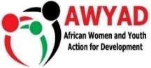
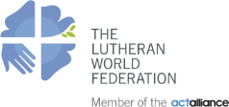

Ali’s Story: Survivor of Child Labor in Busoga region
Child’s name: Ali
Project name: Accelerating action to eliminate child labor practices along the agriculture value chain in Busoga sub region.

Implementing partner: African Women and Youth Action for Development (AWYAD)
Funder: European Union
Location: Mayuge district

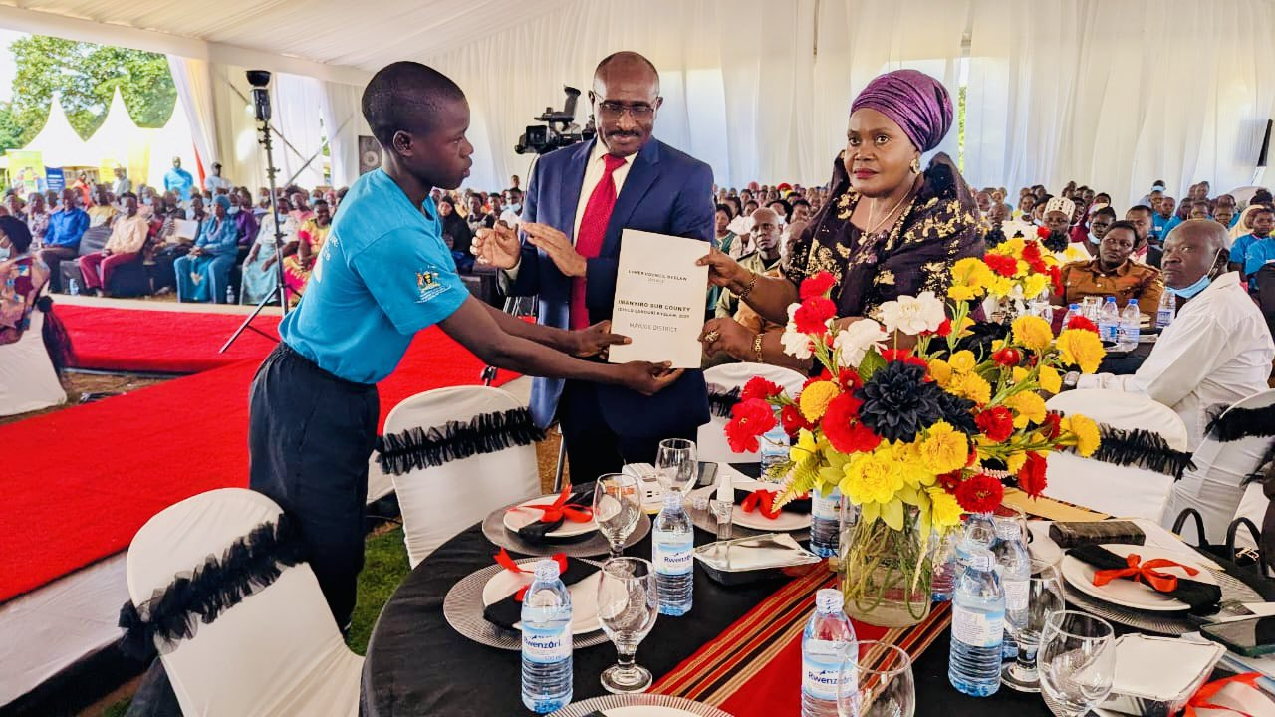Bakali Ali presenting a copy of the child labour by-law to the Guest of Honour, Rt Hon Rukia Nakadama Uganda’s Third Deputy Prime Minister. After his testimony during the Child Labour Day celebrations in Mayuge,

At 15 years old Ali now dreams of passing his Primary Leaving Examinations and becoming a doctor. Not long ago, these dreams seemed impossible. Instead of sitting in a classroom, Ali spent his days under the scorching sun, cutting sugarcane and struggling to raise money to return to school. His story is a powerful reminder of the harsh realities of child labour and the hope that education can restore.
When Childhood Was Taken Away
Ali's life began to change when his father married another wife and left the family behind.
"My father stopped supporting us. Life became very difficult for my mother and all of us children," Ali recalls.
With no reliable source of income, the family struggled to afford even the most basic necessities. School fees, uniforms, and books became luxuries they could no longer afford. One by one, Ali and his siblings dropped out of school. At just nine years old, while still in Primary Three, Ali was forced to put aside his books and join other numerous village children cutting sugarcane for economic survival. His mother bought him a panga so he could work and help provide for the family. This presented the beginning of a difficult chapter that no child should ever have to face.
Soon, Ali was recruited to work in a sugarcane plantation in Bugweri District. For three weeks, he lived far from home with other workers - children and adults, sleeping in crowded accommodation provided by the employer and spending long days cutting sugarcane. Every week, the workers waited eagerly for their pay. Ali hoped that the income he received would help him and his family escape their struggles. But tragedy struck. One night, while he slept, the money he had worked so hard to earn was stolen.
"It was painful because I knew how much I had suffered to get it," he says.
Afraid of the older youths around him, many of whom intimidated younger workers, Ali stayed silent. He felt powerless and alone.
A Dream Almost Lost
He knew it still wasn't enough to get him back to school. After three exhausting weeks, Ali returned home believing that his remaining earnings would finally help him return to school. Instead, he discovered that his mother had used the money to buy medicine for his younger siblings. Ali understood why she had done it, but the news broke his heart.
"I thought that was the end of my education," he says quietly.
For a child who once dreamed of studying and becoming a medical doctor, learning and building a career, it felt as though the door to his future had closed forever. A few days later, he found another opportunity to cut sugarcane and earned UGX 5,000. He bought two exercise books and two pens, holding on to a small piece of hope. Yet deep down
Peer to peer community empowerment
One evening, while fetching water at a community borehole, Ali met his friend James. As they talked, James listened to Ali's struggles and encouraged him not to abandon his education.
"He kept telling me that I should return to school," Ali remembers.
James was a member of the Child Rights Club (CRC) at St. Jude Mbaale Primary School and believed that every child deserved an education. The CRC members are students in school trained by AWYAD to strengthen child participation in their protection and rights promotion. What seemed like an ordinary conversation became a turning point in Ali's life. Sometimes, all it takes is one person who believes in you when you have stopped believing in yourself.
A Second Chance
Through the European Union-funded project Accelerating Action to Eliminate Child Labour Practices Along the Agriculture Value Chain in Busoga Sub-region, implemented by the African Women and Youth Action for Development (AWYAD), Ali was identified and supported to return to school.
Finally, after spending two years trapped in child labour, he was re-enrolled in Primary Four. Returning to school should have been a happy moment, but it was not easy. Ali carried not only the memories of child labour but also the same evidence of a poor household. His school shorts were badly torn.
"I used to sit near the wall so nobody would see the holes in my shorts. Sometimes I covered them with my books," he recalls.
While other children laughed and played, Ali often worried about being judged. Recognizing his self-isolation, and lack of self-confidence that Ali carried, AWYAD provided psychosocial support and counselling, helping him rebuild his confidence and self-worth. The project also provided scholastic materials to support his studies. Then, one of his teachers did something Ali will never forget. The teacher bought him a new school uniform. It may have seemed like a small gesture, but to Ali it meant everything. For the first time in a long time, he felt seen, valued, and respected.
"People started seeing me differently. I also started believing in myself again," Ali says.
From Child Labour Survivor to Child Rights Champion. Today, Ali is preparing to sit for his Primary Leaving Examinations a milestone he once thought he would never reach. But his story does not end there.
Having experienced exploitation firsthand, as a trained CRC member, Ali has become one of the strongest advocates against child labour in his community. He encourages parents to keep their children in school and speaks out against employers who hire children for hazardous work.
He believes that every child deserves the opportunity he was given a chance to learn, grow, and pursue their dreams.
"I believe many children will now be rescued from child labour and achieve their career dreams," he says.
A Future Filled with Hope
Ali's journey is a testament to the power of education, community support, and child protection. A boy who once spent his days cutting sugarcane to survive is now preparing for national examinations and inspiring others to believe that no child's future should be determined by poverty or child labour.
His story reminds us that behind every child labour statistic is a child with dreams worth fighting for. He now dreams of continuing his education through secondary school and university. Inspired by his own experiences of hardship and the support he received, Ali hopes to become a medical doctor so he can help provide quality healthcare to vulnerable children and families in his community. He believes that by helping people stay healthy, he can give them hope just as education gave him a second chance
"I thought my education was over. Today, I am preparing for my future. Education gave me another chance at life." - Ali
Ali`s message
“I want to become a doctor so i can save lives and help people who cannot afford treatment. I also want to encourage every child to stay in school because education can change your life just as it has changed mine.
To all parents, please support your children to remain in school even when life is difficult. Child labour may provide money for today but education gives children a brighter future. Every child deserves the opportunity to learn, achieve their dreams and become someone who can help their family and community.”
He applauded AWYAD for supporting Mayuge district local government in the development of the child Labour by-law for Imanyiro subcounty and a child labour referral pathway.

www.awyad.org

